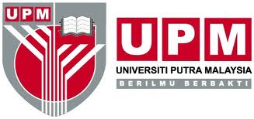
Office use only

Date of PTJ receive:

Date of scientific merit review:

Date of IACUC receive:

INSTITUTIONAL ANIMAL CARE AND USE COMMITTEE (IACUC)
Universiti Putra Malaysia

Check list for ApplicantS

Please check [√] and enclose the following documents as itemised below.
*Please send TWO hardcopies AND softcopy to iacuc@upm.edu.my.
Documents |  | Applicant | IACUC Secretariat  (for office use only)
1. | *Scientific merit review
2. | *Brief research proposal
3. | AUP Form (101/102)
4. | Client consent form (104)- if applicable
5. | *AUP checklist and review form (107)
6. | *One or two pertinent research paper(s) related to the proposed animal study
7. | Supporting document(s) (animal monitoring sheet, grant offer letter, permit etc.)
8. | Fee Charge Form (Please provide the copy of UPM’s official receipt or proof of payment) -NOT APPLICABLE FOR UPM UNDERGRADUATE STUDENT
Signature:

Name:

Date:

Scientific merit requirements are PTJ's responsibilities.
*Documents needed only for AUP Form 101 (Research) application.
http://www.tncpi.upm.edu.my/documentfile

